# Create X-large EC2 instance

# Here is how to connect to EC2

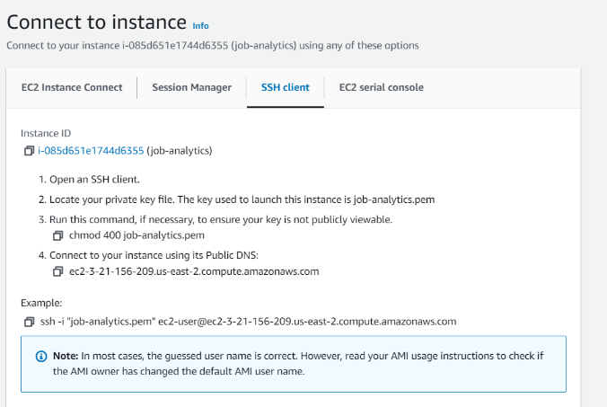

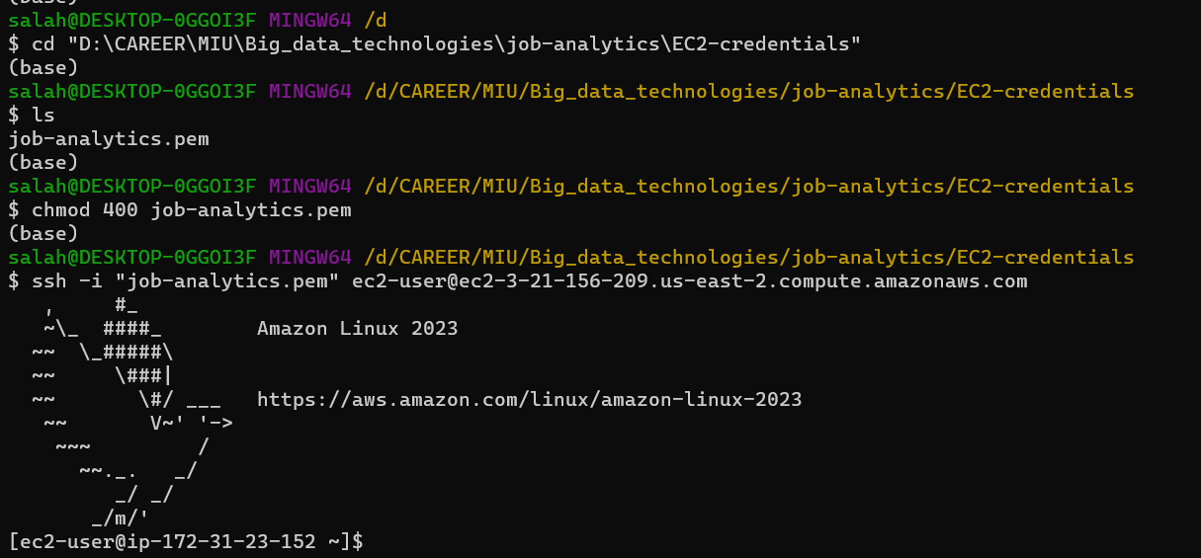

# Copy docker file to EC2

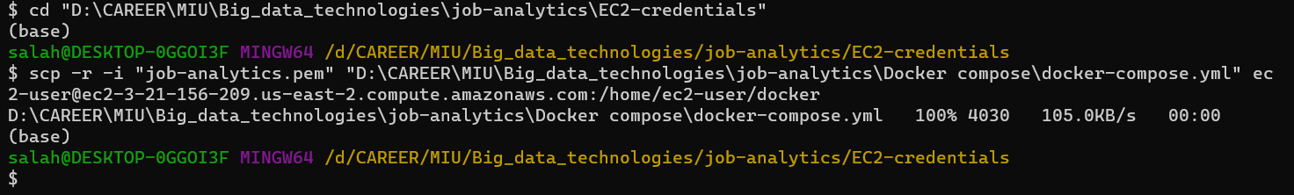 updates all installed packages and their dependencies on a Linux system using the Yum package manager

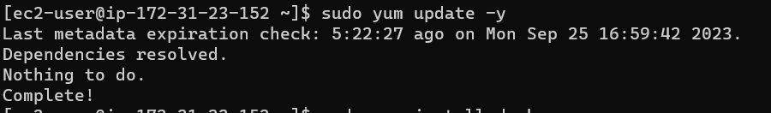

# Install docker

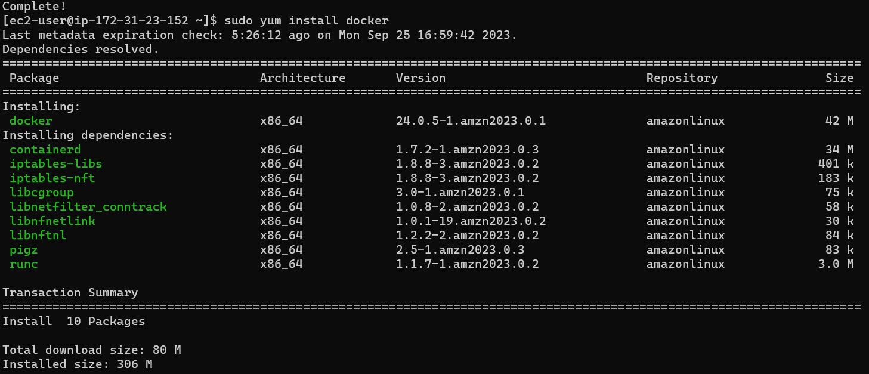

# Install docker compose

Curl: allows you to download a file over Https. -L : allows you to give the link

The $(uname -s) and $(uname -m) parts are command substitutions that allow the script to dynamically determine the OS and architecture to download the right Docker Compose binary.

Specifically:

$(uname -s) - uname -s prints the name of the operating system. So on Linux this would print "Linux", on MacOS it would print "Darwin". This allows picking the right OS binary.

$(uname -m) - uname -m prints the system architecture. For example "x86_64" on 64-bit Intel/AMD systems. This allows picking the right architecture binary.

-o: allows you to specify where you want to store the file you downloaded

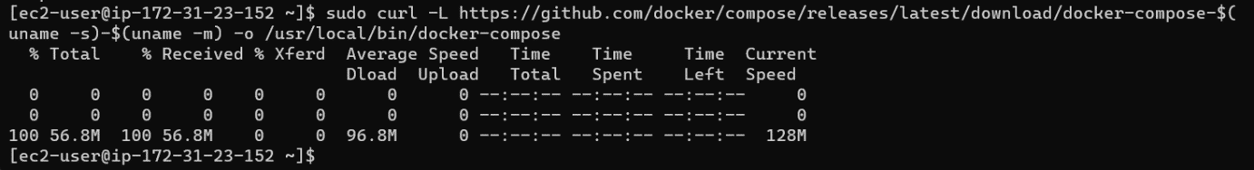

# Setting the execute permission on the docker-compose



# Use docker compose up to pull images and run containers

# Then go to the shell of kafka to create a topic

You first need to use kafka’s bash. In docker here is the command:

Docker exec -i -t kafka bash

Then you create the topic with the command:

Kafka-topic.sh --create --topic your-topic-name –partitions 1 –replication-factor 1 –if-not-exists –zookeeper zookeeper:2181

When you set your producer and send messages. If you want to check if the messages are indeed sent you can use the command:  
kafka-console-consumer.sh --topic your_topic_name --bootstrap-server localhost:9092 --from-beginning

# Create Cassandra keyspace and table

Go to Cassandra terminal using :

docker exec -i -t cassandra bash

interact with Cassandra cluster using CQL by typing command : (username and password are Cassandra by default)

cqlsh -u myusername -p mypassword

create keyspace:

CREATE KEYSPACE IF NOT EXISTS jobs_analytics WITH replication = {'class': 'SimpleStrategy', 'replication_factor': 1}

CREATE TABLE IF NOT EXIST jobs_analytics.job

Create a table:

CREATE TABLE IF NOT EXISTS jobs_analytics.job (title Text, company_name Text, job_date Date, job_link Text, job_location Text, job_seniority_level Text, job_employment_type Text, job_function Text, job_industries Text, number_applicants int, job_description Text, Primary key ((job_date, job_seniority_level, job_location), company_name, title));A computer screen with white text

# Create a folder in hdfs:

Docker exec -i -t namenode bash

hdfs dfs -mkdir -p output1/scraped_jobs/

